

Mobivue PMMS

Ajanta Pharma Ltd.

Sampling

This document includes the functional and non- functional requirements for specification of the application designed for Ajanta Pharma.

BAR CODE INDIA, 145 Udyog Vihar Phase 1, Gurugram, Haryana-122016, PH: 0124 4337555 1

Prepared By: Leena
Version Number: 1.0
BAR CODE INDIA, 691 UDYOG VIHAR PHASE V, GURUGRAM, HARYANA - 122016, Ph.: 0124 4337555

Sampling

Cubicle Assignment
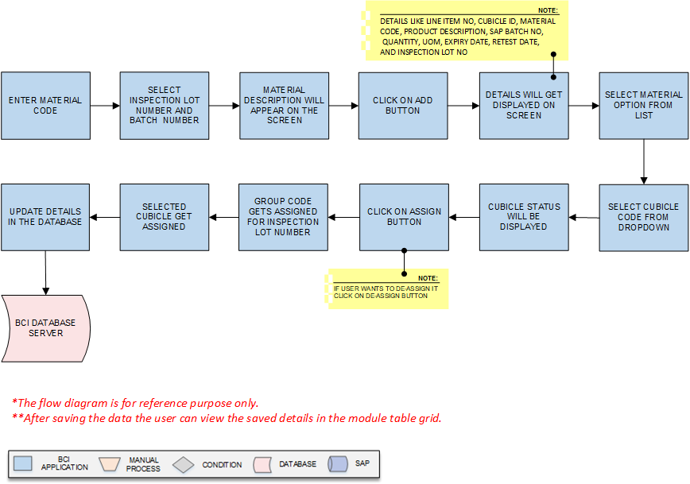
Activities
Module Description | This module will be used to assign cubicle for sampling of Raw material and Packing material against the Inspection Lot/A.R.No.

Pre-Conditions | - Inspection Lot details needs to be imported from SAP.

Process Steps | - Enter the Material Code.  - Select the Inspection Lot Number, Batch Number from the dropdown list.  - Material Description and other details will be appear on the screen.  - Click on Add button.  - A grid format of, Line Item No, Cubicle id, Material Code, Product Description, SAP Batch No, Quantity, UOM, Expiry Date, Retest Date, and Inspection Lot No will be displayed on the screen.  - User will select checkbox of the Material from the list for which assignment is needed (If required).  *User can select multiple material from the list.  - Select the Cubicle Code from dropdown; in which the material is to be assigned for sampling.  - Cubicle Status for the material will be displayed.  - Then click on Assign button.  *Incase user wants to de-assign cubicle, select the material line from the list and click on De-Assign button.  - The group code gets assigned for inspection lot number to the selected materials.  - Data gets updated in database.

Post-Conditions | - Further process of sampling will be proceed.

Validations | - While creating group, system will validate material details data is imported from SAP.  - While assigning cubicle, system will validate whether the material SAB batch no. is not already assigned to other cubicle.  - An alert will be displayed in case of invalid Material Code is entered.

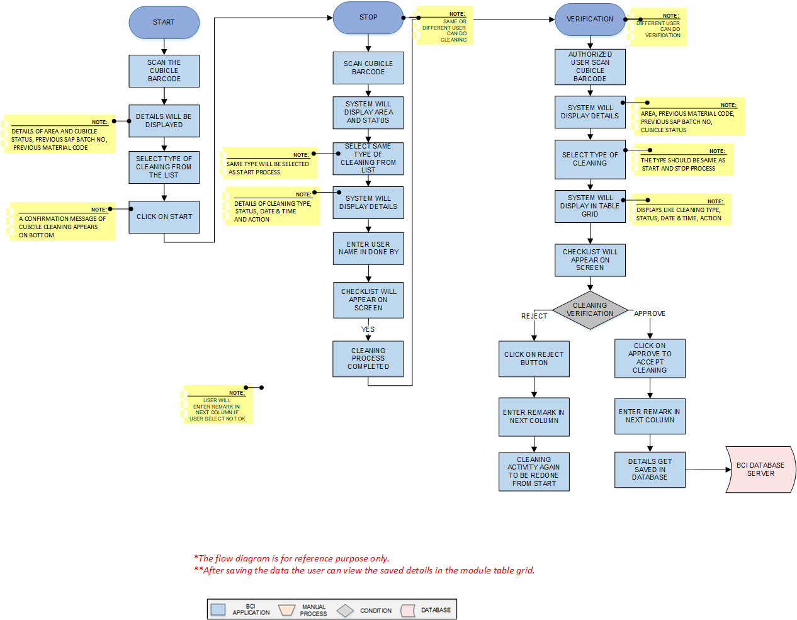
Cubicle Cleaning

Activities
Module Description | This module will be used for Cubicle cleaning process.

Pre-Conditions | - Cubicle status can be clean/unclean/not in use in system.

Process Steps | 1. Cleaning  - Start: - User will scan Cubicle Barcode which is applied on cubicle door.  - Area and Cubicle Status, Previous SAP Batch No, Previous Material Code, will be displayed on the screen.  - Select the type of cleaning from the dropdown list.  - Then click on Start button, system store as start time in database against the cubicle.  - The Cubicle Cleaning added successfully message appears on bottom.  - Stop :- After cleaning procedure Scan the Cubicle Barcode.  - Selected Area and Cubicle Status will be displayed on the screen.  - Select the same type of cleaning used for start from the dropdown list.  *Same Type will be selected as start process.  - System will display Cleaning Type, Status, Date & Time and Action Taken by user details in the table grid.  - Enter cleaning done person name.  - Checkpoints will be displayed on the screen.  - User will verify the cleaning and update observations in the checklist  - After completing the check list, user will click on Stop button.  - System will store date and time as cubicle cleaning Stop time.  - Cubicle has been cleaned stopped successfully notification will appear on the screen.  - If cleaning is not satisfactory as per the checkpoints, user to enter the remark in the remark column.  - Verification:  - Authorize user will scan the Cubicle Barcode.  - Area, Previous Material Code, Previous SAP Batch No, Cubicle Status will be displayed on the screen.  - Select Type of cleaning from dropdown.  *The type should be same as Start and Stop process.  - System will display Cleaning Type, Status, Date & Time, Action Taken By in the table grid.  - Checkpoints will be displayed on the screen.  - Click on Is Verified Checkbox.  - Enter Approval/Rejection Description.  - User will click on Approve or Reject and enter the remark.  - After rejection cubical cleaning system should allow re-cleaning of the cubicles  - Click on Clear to clear all the details in the fields.  - Click on Close to close the current cleaning window.  - Data gets updated in the database

Post-Conditions | - Cubicle status will be changed to clean

Validations | - Sequence of cleaning will be followed as Cleaning Start, Cleaning Stop and Verification  - An error message will be displayed in case of different cleaning type is selected.

Equipment Cleaning
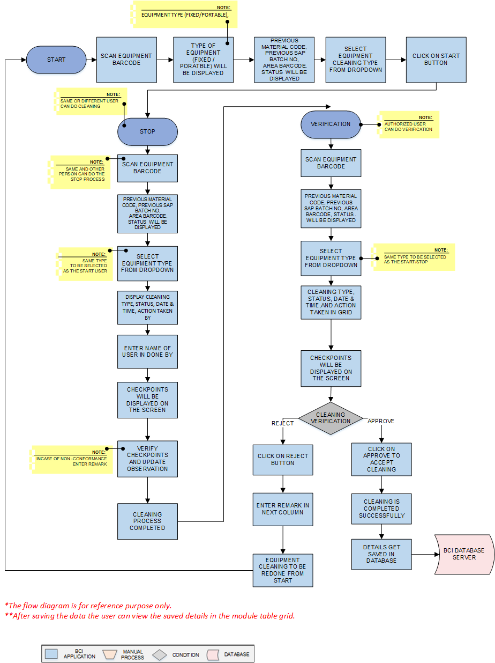

Activities
Module Description | This module will be used for Equipment cleaning process.to log

Pre-Conditions | - Equipment status should be unclean and not in use in system.

Process Steps | Equipment cleaning will be done in 2 steps.  - Cleaning  - User will scan Equipment Barcode which is applied on Equipment.  - Equipment type (fixed/portable), Previous Material Code, Previous SAP Batch No, Area Barcode, Status and other details will be displayed.  - Select the Equipment Cleaning Type from the dropdown list.  - Then click on Start button, system store as start time in database against the equipment.  - User will scan Equipment Barcode which is applied on Equipment.  *Same or other person can do the stop process.  - Previous Material Code, Previous SAP Batch No, Area Barcode, Status and other details will be displayed on the screen.  - Select the Equipment Cleaning Type from the dropdown list.  *Same type to be selected as the start process.  - System will display Cleaning Type, Status, Date & Time, Action Taken By  - Enter the name of the person cleaning done by.  - Checkpoints will be displayed on the screen.  - User will verify the checkpoints and update the observations incase of any non-conformance compulsory remark will be enter.  - User will check if the observation is not satisfactory then user will enter remark in next column.  - After completing the check list, user will click on Stop button.  - System will store date and time as cubicle cleaning Stop time.  - Equipment has been cleaned stopped successfully notification will appear on the screen.  - Verification:  - Authorized user will scan Equipment Barcode.  - Previous Material Code, Previous SAP Batch No, Area Barcode, Status and other details will be displayed on the screen.  - Select the Equipment Cleaning Type from the dropdown list.  *Same type to be selected as the start and stop process.  - System will display Cleaning Type, Status, Date & Time, and Action Taken By in grid format.  - Checkpoints will be displayed on the screen.  - User will check if the observation is not satisfactory then user will enter remark in next column.  - Click on Is Verified Checkbox if Cleaning found satisfactory.  - Enter Approval/Rejection Description  - User will click Approve or Reject based on observation and enter remark.  - System should allow to re-clean the equipment in case of Rejection and do not allow to proceed next steps.  *If user click on Reject then user will enter remark in next Approval/Reject column.  - After rejection cubical cleaning activity again to be redone by start .  - Select Is Verified check box to get the cleaning process verified.  - Click on Approve to accept the cleaning activity as completed.  - Click on Clear to clear all the details in the fields.  - Click on Close to close the current cleaning window.  - Data gets updated in the database and SAP.

Post-Conditions | - Equipment assignment will be done.

Validations | - Sequence of cleaning will be followed as Equipment Cleaning Start, Equipment Cleaning Stop and Equipment Cleaning Verification  - An error message will be displayed in case of different cleaning type is selected.

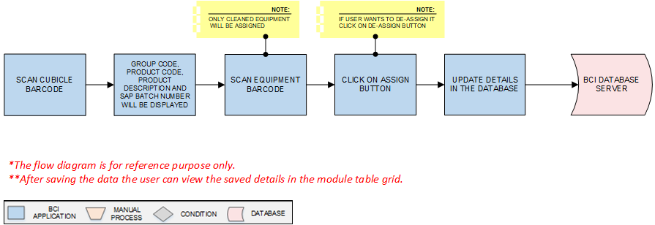
Equipment Assignment

Activities
Module Description | This module will be used for Equipment assigning process.

Pre-Conditions | - Equipment status should be clean in system.

Process Steps | - User will scan Cubicle Barcode in which equipment is placed.  - The Group code, Product code, Product Description and SAP Batch Number and other details will displayed on the screen.  - User will scan Equipment Barcode which is applied on Equipment.  *Only cleaned equipment will be assigned.  - Click on Assign button, the equipment gets assigned to that cubicle.  *User will click on De-Assign button, to de-assign the equipment to that cubicle as per requirement.  - Selected equipment will be assigned.  - Click on Clear to clear all the details in the fields.  - Click on Close to close the current cleaning window.  - Save the details in database.

Post-Conditions | - Equipment will be assigned to the cubicle.

Validations | - Unclean equipment should not allowed for the assignment.  - Alert message will be displayed in case of invalid Cubicle Barcode is entered.  - Alert message will be displayed in case of invalid Equipment Barcode is entered.

Line Clearance
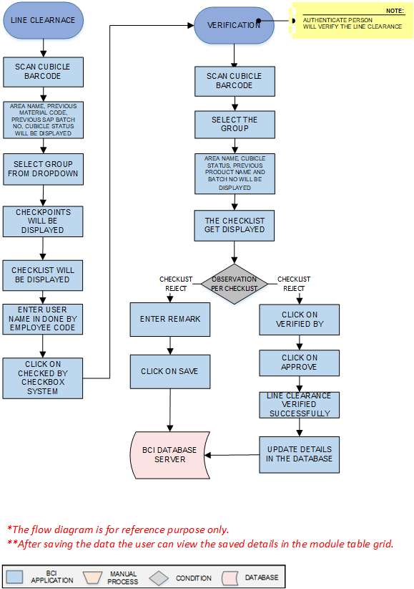
Activities
Module Description | This module will be used for line clearance.

Pre-Conditions | - Cubicle and equipment status should be clean in system.

Process Steps | - Line Clearance  - Scan the Cubicle Barcode.  - Area Name, Previous Material Name Code, Previous SAP Batch No, Cubicle status will be displayed for the cubicle.  - Select the Group from the dropdown list.  - Checkpoints will be displayed on the screen.  - User will check the points as per the checklist and update observation details if any check point not found satisfactory then user will enter remark in next column if he is not satisfactory.  - Enter the employee code of the done by person system will display name of the person from system data base.  - Click on Checked by checkbox system will update checked by details as per the current user details.  - Line clearance verification can done on same screen :-.  *On same system, Authorized person will select Verified By and login with his credentials. System will store date, time and login user id. Line clearance will be approved successfully on the same system by authorize user. If anything is found non satisfactory then user will click on Reject button.  - Line clearance added successfully notification will appear on the screen.  - Verification  - Scan the Cubicle barcode.  - Select the Group from the dropdown list.  - Area Name, Previous Material Name, Previous SAP Batch No, Cubicle status will be displayed for the cubicle System will be displayed  - checkpoints selected while line clearance  - User will update the checklist as per the observation incase any non-conformance observation user will enter the remark details.  - Then click on Approve button.  - The Line clearance approved successfully message pop up.  *If anything is found non satisfactory then user will click on Reject button and enter remark.  - Data gets updated into the database.  Line clearance not required for the packing materials , Picking& Pre-staging activity can be performed before line clearance

Post-Conditions | - Line clearance will be completed.

Validations | - An alert should be displayed in case duplicate/ invalid Cubicle Barcode is entered.  - An alert should be displayed in case duplicate/ invalid Cubicle Group is selected

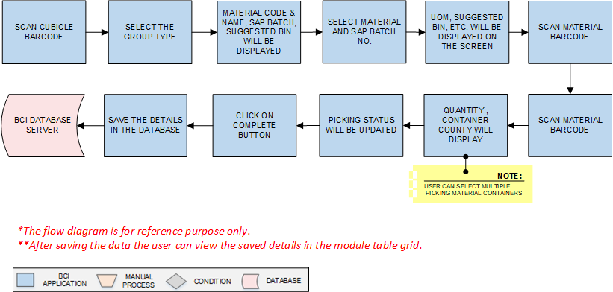
Picking
Activities
Module Description | The Module will be used to Pick material from Location and place in Pre stage area.

Pre-Conditions | - Group needs to be created.  - Material is allocated in location.

Process Steps | - Scan the Cubicle Barcode.  - User will select the Group from the dropdown list.  - A grid format of Material code, material name, SAP Batch No, Suggested Bin will appear on the screen.  - Select Material and SAP Batch No. from drop down list.  - UOM, Suggested Bin, Scan Bin Previous quantity, Container Count, Quantity, Picking Status, Last Scan will be displayed on the screen.  - Scan Material Barcode.  - After scanning of the container last scanned, quantity , container county will display and picking status will be updated  *User can select multiple picking material containers  - Click on Complete button.  - User will click on Clear button to clear the data.  - User will click on Close button to close the picking.  - Data gets updated in the database

Post-Conditions | - Material will be placed in Pre Stage area.

Validations | - An alert should be displayed in case duplicate/ invalid Cubicle Barcode is entered.  - An alert should be displayed in case duplicate/ invalid Group is selected  - An alert should be displayed in case duplicate/ invalid Material is selected.  - An alert should be displayed in case duplicate/ invalid Bin is entered.  - An alert should be displayed in case duplicate/ invalid Material Barcode is entered.

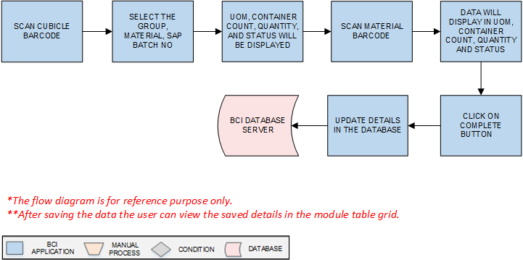
Pre Staging
Activities
Module Description | This module will be used to validate material movement from pre staging area to staging.

Pre-Conditions | - Material Picking is completed

Process Steps | - Scan the Cubicle barcode.  - Select the Group, Material a grid view of material and SAP batch no will display.  - Select material and SAP batch no from the drop down  - System will display the Container Count, Quantity, UOM and Status. for which picking is completed  - Scan Material Barcode.  - Data will display in UOM, container count, quantity and status  - Click on Complete to successfully approve the pre-stage process.  - User will click on Clear button to clear the data.  - User will click on Close button to close the Pre staging.  - System will updated as status as material pre staged.  - Data gets updated in the database and SAP.

Post-Conditions | - Perform staging
Validations | - An alert should be displayed in case duplicate/ invalid Cubicle Barcode is entered.  - An alert should be displayed in case duplicate/ invalid Group is selected  - An alert should be displayed in case duplicate/ invalid Material Barcode is entered.

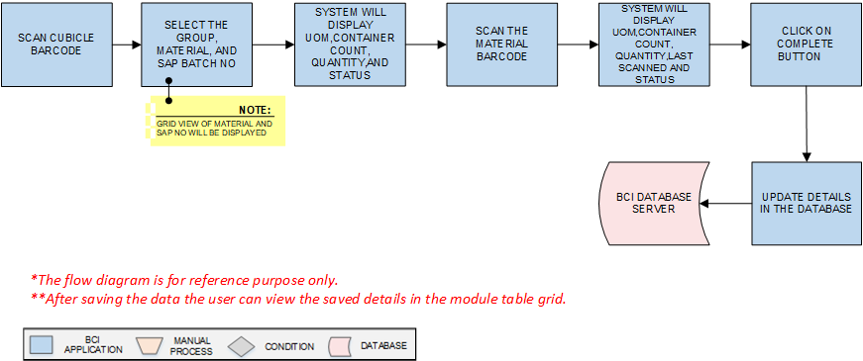
Staging
Activities
Module Description | This module will be used to validate material movement from staging area to Sampling.

Pre-Conditions | - Material pre-staging Picking is completed.  - Line clearance should completed

Process Steps | - Scan the Cubicle Barcode.  - Select the Group.  - Grid view of the Material and SAP batch no will display.  - Select Material, and SAP Batch No from the dropdown list.  - System will display the Container Count, Quantity, UOM, and Status. for which picking is completed  - Scan the material bar code , data will display in UOM, Container count, Quantity , last scanned and status--  - Click on Complete to approve the staging.  - User will click on Clear button to clear the data.  - User will click on Close button to close the Pre staging.  - System will updated as status as material approved of staging.  - Data gets updated in database .

Post-Conditions | - Ready to perform Sampling

Validations | - An alert should be displayed in case duplicate/ invalid Cubicle Barcode is entered.  - An alert should be displayed in case duplicate/ invalid Group is selected  - An alert should be displayed in case duplicate/ invalid Material is selected.  - Only presaged material can be scanned in Staging.

Sampling
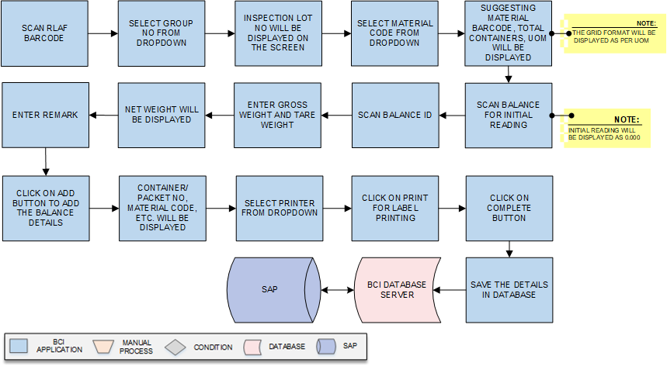
Activities
Module Description | This module will be used to sampling of the material material

Pre-Conditions | - Staging of the material is completed.

Process Steps | - Scan the RLAF Barcode.  - Select Group Code from dropdown.  - Inspection Lot No will be displayed on the screen.  - Select Material Code and SAP batch no. from dropdown.  - Suggesting Material Barcode, Total Containers will be displayed on the screen  - UOM will be displayed on the screen.  Based on the UOM (KG & No) further screen will be display.  - For the Material of which UOM is KG: -  - Scan Balance for initial reading in Balances section.  *Initial reading will be displayed as 0.000.  - Scan Balance Id.  - Enter Gross weight and Tare weight.  - Net weight will be displayed on the screen after auto calculation by the system.  - Enter Remark.  - Click on Add button to add the Balance details.  - A grid format of Container/Packet No, Material Code, SAP Batch No, Sample Quantity, UOM, Done By, Remark, Action will be displayed on the screen.  - Select the printer from the dropdown list.  - Then click on Print button then the label will be printed.  - After completing sampling for that material, user will click on Complete button, system will note the process for sampling.  - User will click on Clear button to clear the data.  - User will click on Close button to close the Sampling.  - Data gets updated in the database and SAP.

Post-Conditions | - Sampled label will be generated.

Validations | - An alert should be displayed in case duplicate/ invalid RLAF is entered.  - An alert should be displayed in case duplicate/ invalid Group Code is selected  - An alert should be displayed in case duplicate/ invalid Material Code is selected.

Stage Out
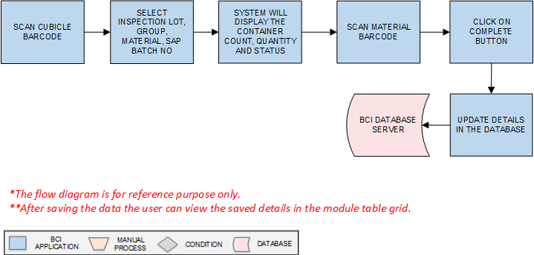
Activities
Module Description | This module will be used stage out the Material from cubicle.

Pre-Conditions | - Sampling should be completed

Process Steps | - Scan the Cubicle Barcode.  - Select Inspection Lot, Material, SAP Batch No from the dropdown list.  - System will display the Container Count, Quantity and Status. for which stage out is required  - Scan Material Barcode for loose material which is to be reallocated details will be updated as per material.  - Click on Complete button.  - User will click on Clear button to clear the data.  - User will click on Close button to close the Stage Out.  - Data gets updated in the database and SAP.

Post-Conditions | - Container will be removed from the cubicle.

Validations | - An alert should be displayed in case duplicate/ invalid Cubicle Barcode is entered  - An alert should be displayed in case duplicate/ invalid Material Barcode is entered.

Putaway
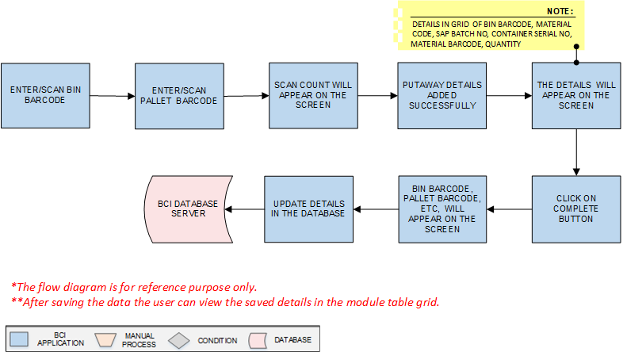
Activities
Module Description | This module will be used to map sample materials in Pallets to Bins and Material to Bins.

Pre-Conditions | - Stage out should be completed.

Process Steps | - Select the type of Put Away i.e. Pallet to Bin or Material to Bin.  *Here we consider Pallet to Bin putaway. Same process will be applied for Material to Bin putaway.  - Enter/Scan Bin Barcode.  - Enter/Scan Pallet Barcode.  - Scan count will appear on the screen.  - Putaway details added successfully.  - A grid format of Bin Barcode, Material Code, SAP Batch No, Container Serial No, Material Barcode, Quantity will appear on the screen.  - Click on Complete Button.  - A grid format of Bin Barcode, Pallet Barcode, Material Code, Material Description, SAP Batch No, Count, and Action will appear on the screen.  - Data is saved in the database and SAP.

Post-Conditions | - Pallet or Material Put Away is completed.

Validations | - An alert should be displayed in case duplicate/ invalid Bin Barcode is entered.  - An alert should be displayed in case duplicate/ invalid Pallet Barcode is entered.  - An alert should be displayed in case duplicate/ invalid Material Barcode is entered.

